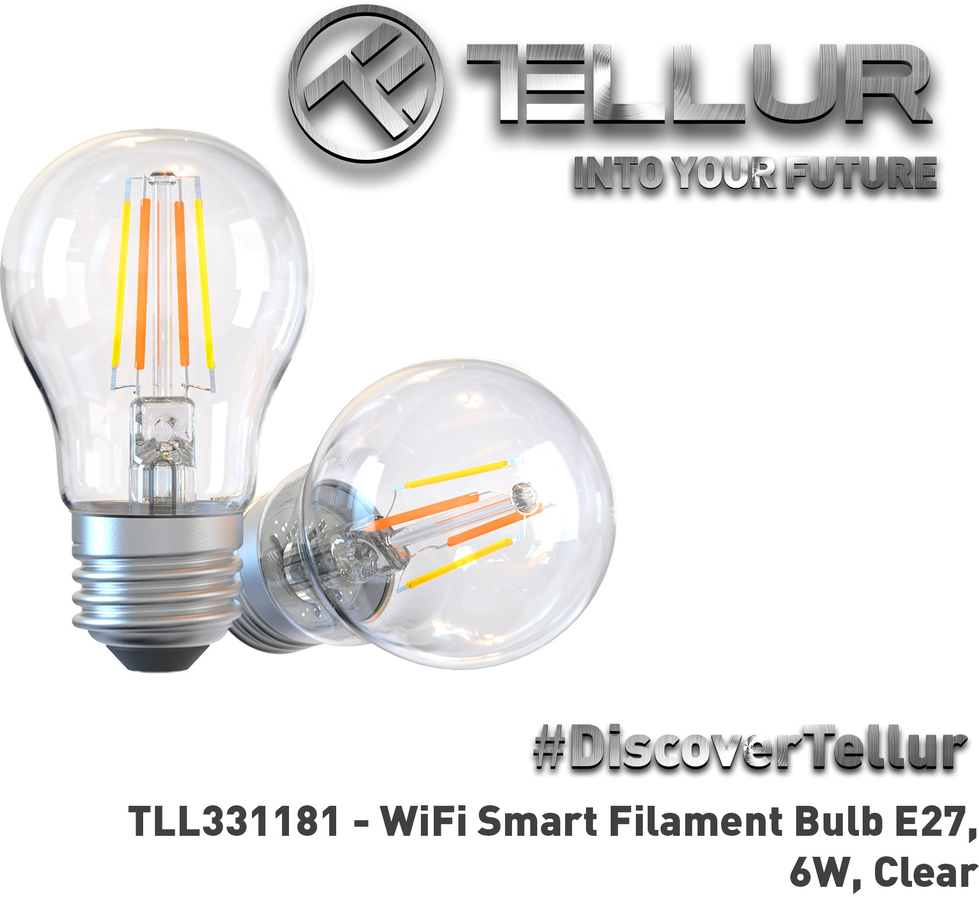

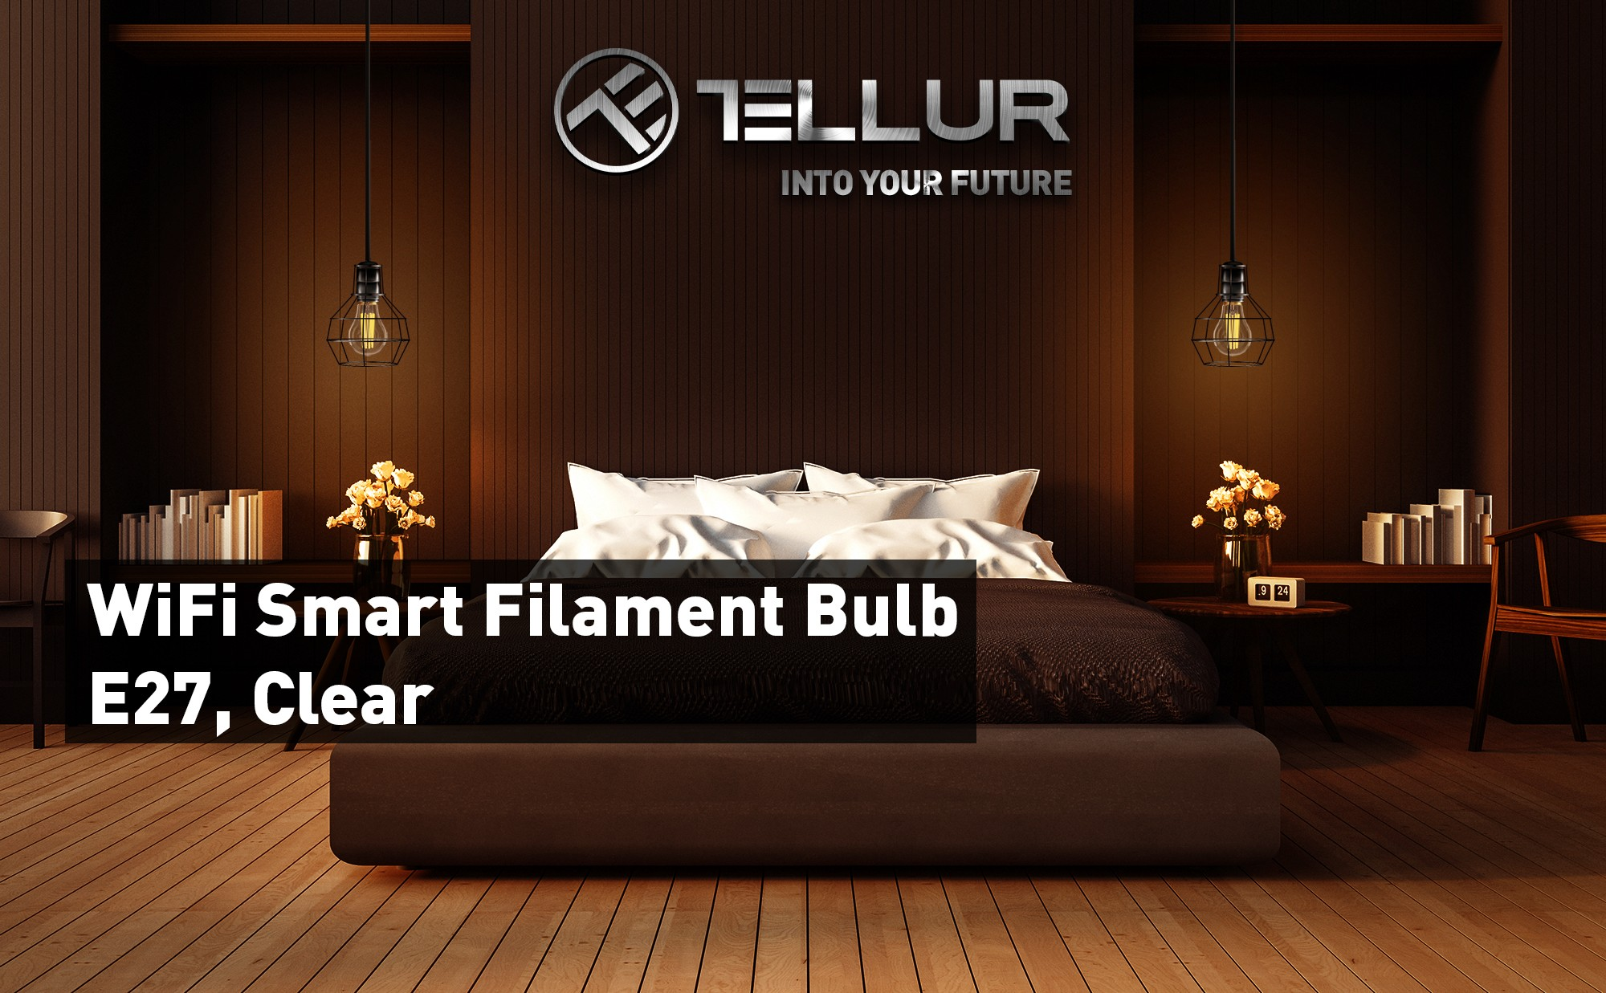

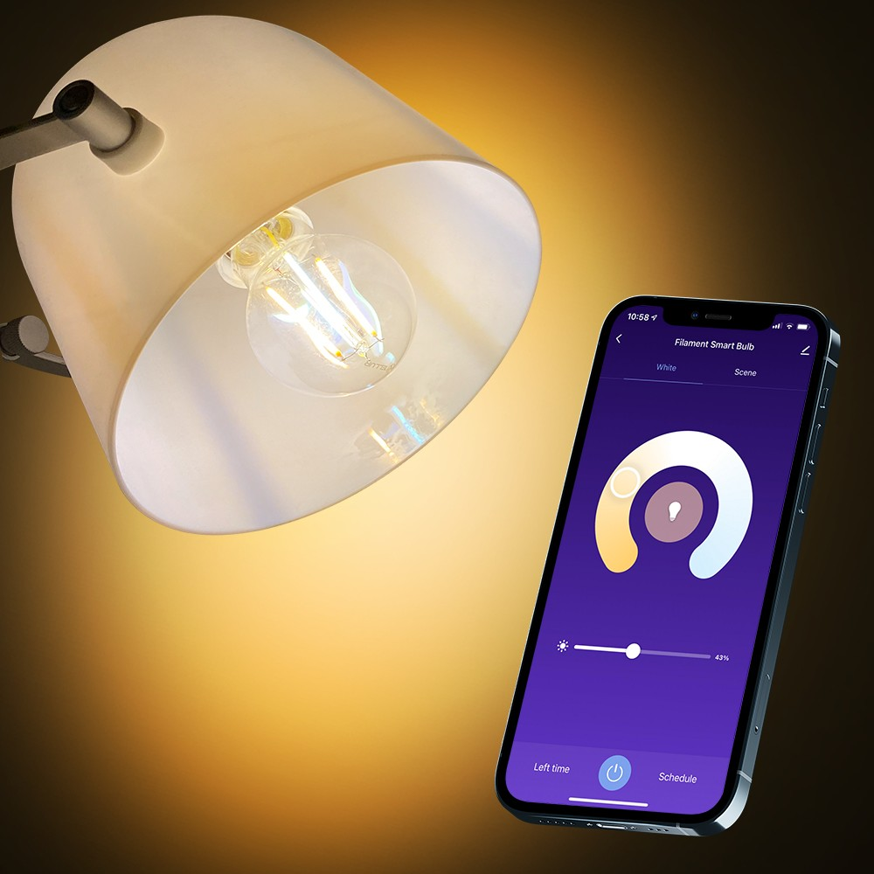

# Works with Siri Shortcuts

**WiFi Smart Filament Bulb E27**

**Give a retro vibe to your home with the WiFi Smart Filament Bulb**

Combining modern day technology with a classic look, this bulb is easy to install and use with Tellur Smart app.

The amber colored bulb offers a warm glow and a more industrial and vintage look.

# Characteristics

* Easy to install and use with Tellur Smart app
* Timer, schedule, integrated functions, fully customizable
* Straight filament & amber bulb give a retro vibe to your home
* Dimmable & warm/white light

Create smart scenario with "Tap-To-Run" function in "Tellur Smart" application

Integrate your new function from "Tellur Smart" app by adding to Siri and rename "When I say" function

Start using your new function giving voice commands to turn on/off the connected device and automatically will execute commands based on your specifications.

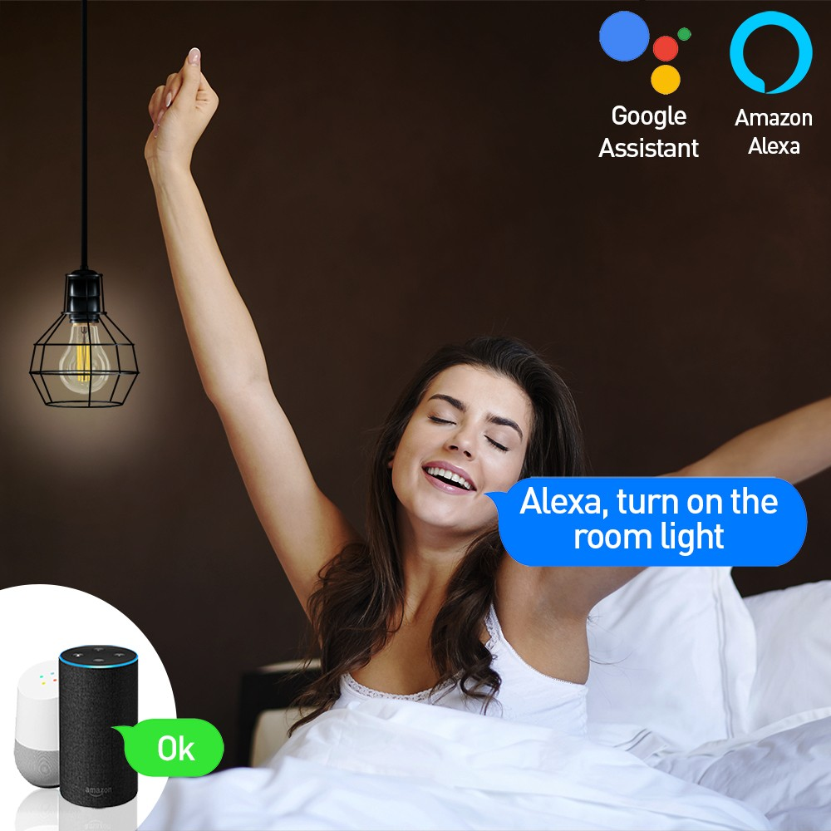 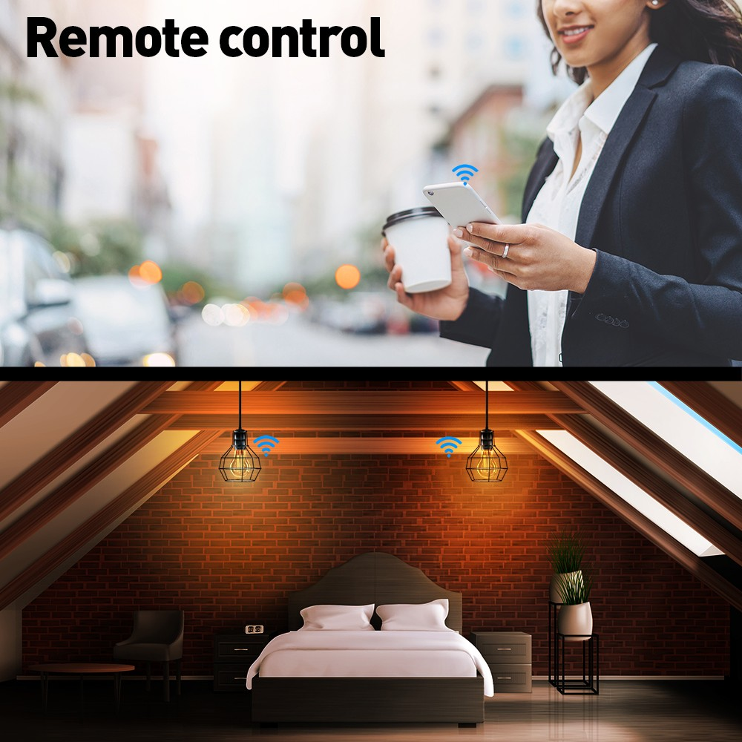

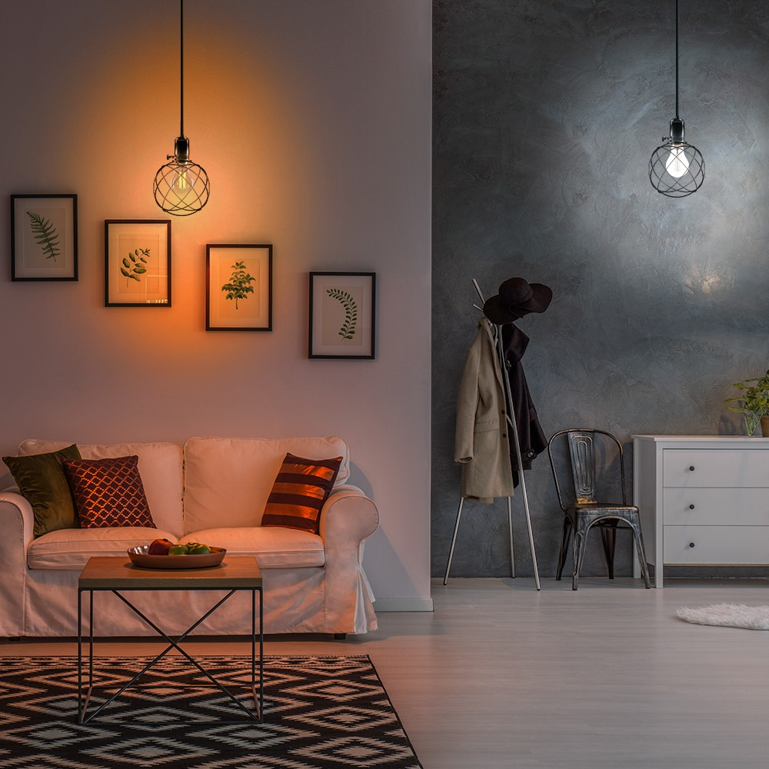

'"·

ooc "'""""'"""""""""' _,,._...,,.._

# Vocal Control

Control your home’s lightning from anywhere via Tellur Smart app – all you need is your smartphone and an active internet connection.

Works with Amazon Alexa (echo, dot and more) and Google Assistant (home, mini and more), allows you to control your light hands free with simple voice commands.

Link the Wi-Fi Smart Bulb Light with Amazon’s Alexa or Google Assistant and control your lights vocally.

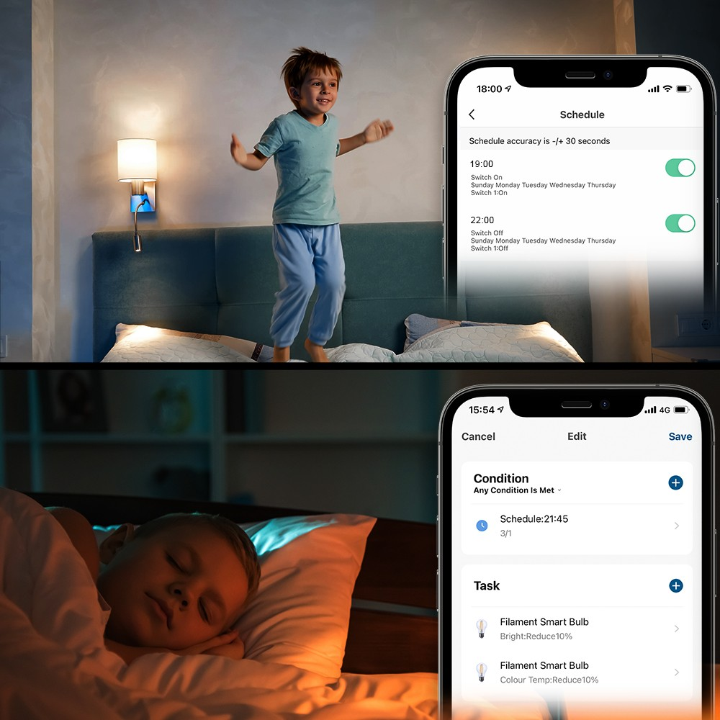

# Automation, Smart Scenarios and Schedule

Fully customizable app.

An automation scenario enables your Wi-Fi Smart AC Socket to execute a command automatically, based on specific conditions.

Set up lighting routines to suit your modern lifestyle and automate your lights - automatically turn on or off at pre-set times.

For example, you can set up to automatically turn on/off light at specific time and passed.

During on/off interval you can set-up an automation scenario to reduce bright intensity and color temperature to 10%, 15 minutes before light turn off.

# Light Adjustment

Customize your light directly from Tellur Smart app, with intensity and warmth options: white or warm light.

Create a cosy relaxing scene with warmer light or a cold light to refresh, concentrate or energize.

Why not turning your living room into a movie theatre.

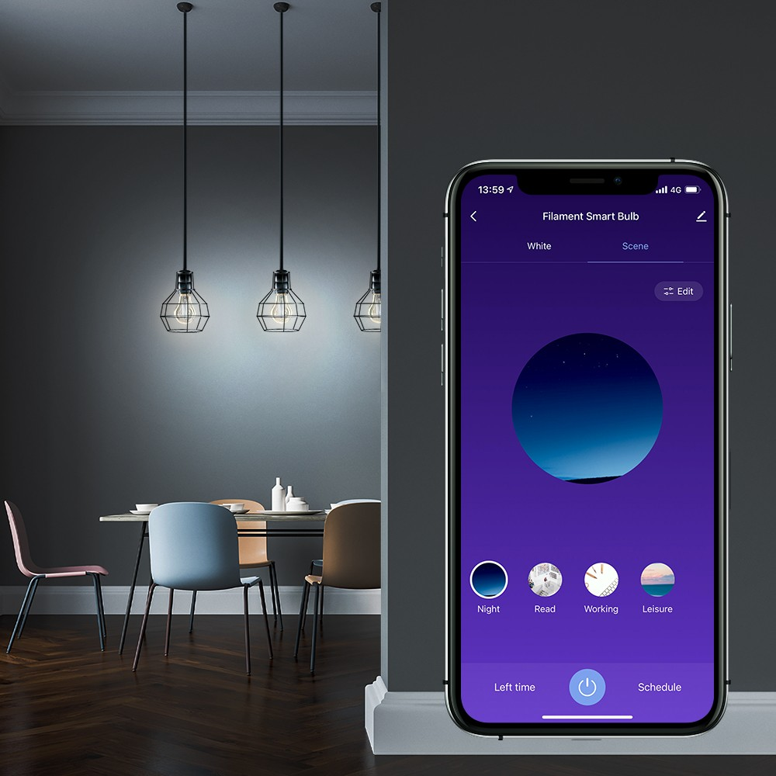

'"·

ooc "'""""'"""""""""' _,,._...,,.._

# Predefined or Customised Scenes

Adjust the bulb brightness and color temperature via Tellur Smart App using predefined scene to satisfy your different lighting requirements on different occasions, creating more comfortable and must warmer living/room spaces.

# Control from anywhere

Control remotely your light whenever and wherever you are in the world via Tellur Smart App.

For example set the lights to automatically turn on and off according to your needs, even when you are away.

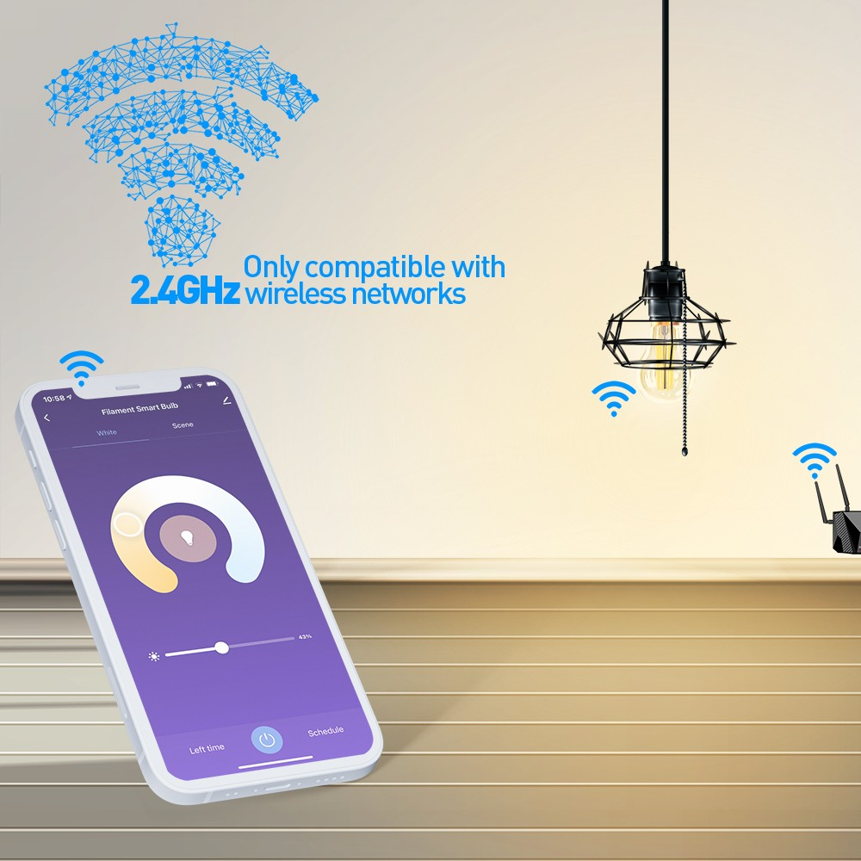

# Easy to install and use

Using Tellur Smart App, Smart Life or Tuya (IOS and Android).

Independent use via the Internet, only with a smartphone. No hub required. Supports up to 150 registered devices. Works only with 2.4GHz wireless networks